Touch sensor（TTP223）

Overview：
This lesson will show how use the touch module to control a LED light.

Materials：
Arduino Uno x 1
Touch switch x 1
DuPont wires x 3

Product description :
The touch module is a capacitive touch switch module based on the touch detection IC (TTP223B). Normally, the module outputs a low level. When the module is touched with a finger, the module outputs a high level.

You could install the module in non-metallic materials (such as plastic, glass) with the four mounting holes. It is then covered by a thin piece of non-metallic material. This could be a hidden keys in walls, desktops and other places. (ensure touch region is correctly located). An advantage of this module is that is simpler than conventional pressure-type keys.

Technical Parameters ：
Low power consumption
Power supply for 2 ~ 5.5V DC
Can replace a traditional button.
Four M2 screws positioning holes for easy installation
Size: 2.4 x 2.4 x 0.7cm(LxWxH)

Wiring diagram:
Arduino Uno <------> Touch sensor
Pin A5 <------> SIG
5V <------> VCC
GND <------> GND
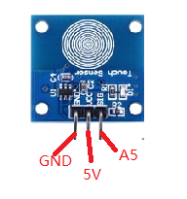
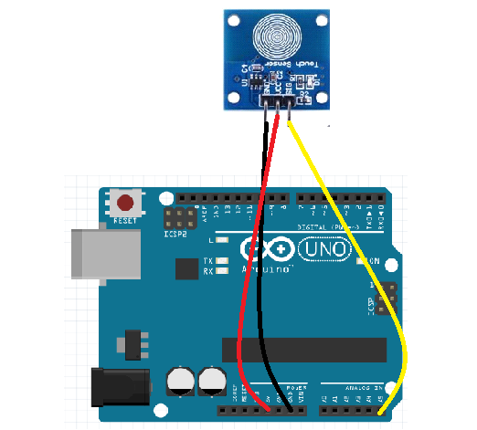

Example code:
const int Qswitch = A5;
void setup()
{
pinMode(Qswitch,INPUT);
Serial.begin(9600);
}
void loop()
{

Serial.println(analogRead(A5));
delay(200);
}

Experimental phenomena：
Print touch information on the serial port.
